Week 1: Data Cleaning and Preliminary Analysis
Dataset: Airline Passenger Satisfaction Dataset
Software: R and RStudio
1. Introduction
The objective of this project is to perform data cleaning and preliminary analysis on an airline passenger satisfaction dataset using R. The process involves identifying missing values, checking duplicate records, detecting outliers, normalizing numerical variables, and encoding categorical variables. These steps help improve data quality and prepare the dataset for further analysis.
2. Dataset Overview
The airline passenger dataset contains information about passenger demographics, travel details, airline services, flight delays, and customer satisfaction. The dataset consists of 103,904 observations and 25 original variables.
Description | Details
Total rows | 103,904
Total columns | 25
Missing values | 310
Duplicate records | 0
RStudio output showing:
dim(raw_data)
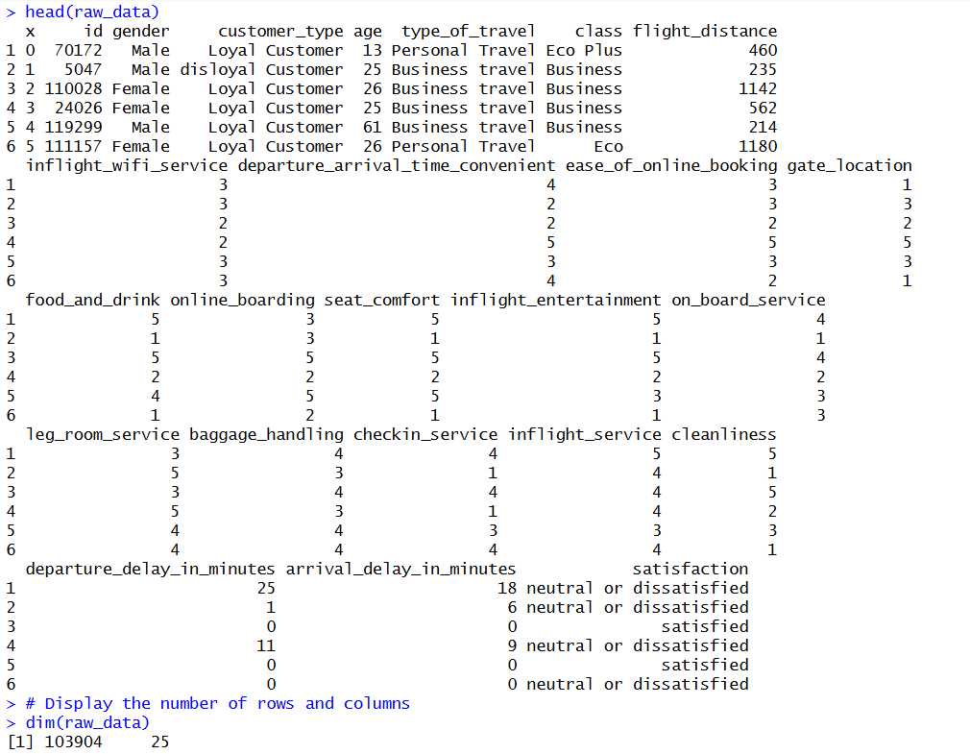
head(raw_data)
3.

Data Structure and Initial Summary
The str() function was used to identify the structure and data types of variables in the dataset. The summary() function was used to obtain an initial overview of numerical distributions and categorical values. This helped understand the dataset before performing data cleaning.
R code:
str(raw_data)
summary(raw_data)
nrow(raw_data)
ncol(raw_data)
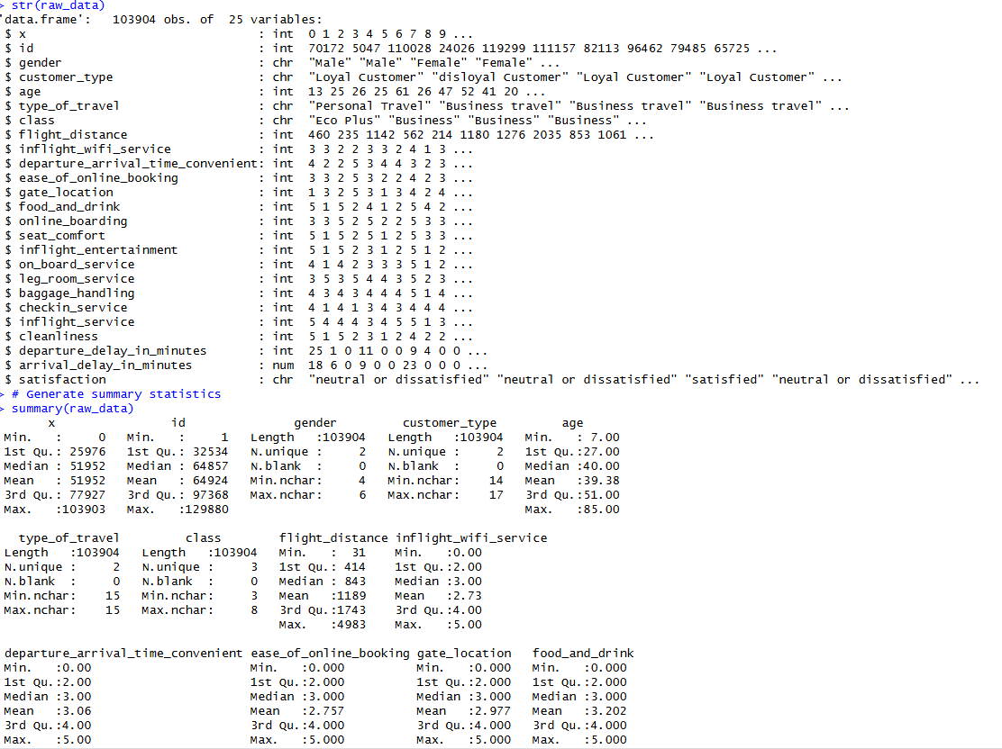
4. Missing Value Analysis
Missing-value analysis was performed using is.na() to identify incomplete observations. The analysis revealed 310 missing values, all located in the arrival_delay_in_minutes variable.
R code:
sum(is.na(raw_data))

colSums(is.na(raw_data))
colSums(is.na(raw_data))[
colSums(is.na(raw_data)) > 0
]
Insert Table 2: Missing Values
Variable | Missing values
arrival_delay_in_minutes | 310
Other variables | 0
Total | 310
4.1 Missing Value Treatment
Mean imputation was applied to replace the missing values in the arrival delay variable. The mean was calculated while excluding missing observations. After imputation, the dataset was checked again and returned zero missing values.
R code:
raw_data$arrival_delay_in_minutes[
is.na(raw_data$arrival_delay_in_minutes)
] <- mean( raw_data$arrival_delay_in_minutes, na.rm = TRUE)sum(is.na(raw_data))

5. Duplicate Record Checking
The duplicated() function was used to identify repeated records in the dataset. The analysis returned zero duplicate records. Therefore, no duplicate removal was necessary.
R code:
sum(duplicated(raw_data))
raw_data[duplicated(raw_data), ]
Show the output:
[1] 0
Caption: Figure 4: Duplicate record checking.

6. Outlier Detection
Outlier detection was performed using boxplots and the IQR method. Three numerical variables were examined: age, flight distance, and arrival delay. The purpose was to identify unusually high or low observations that could influence statistical analysis.
6.1 Boxplots
R code:
boxplot(raw_data$age,
main = "Outliers in Age")
boxplot(raw_data$flight_distance,
main = "Outliers in Flight Distance")
boxplot(raw_data$arrival_delay_in_minutes,
main = "Outliers in Arrival Delay")
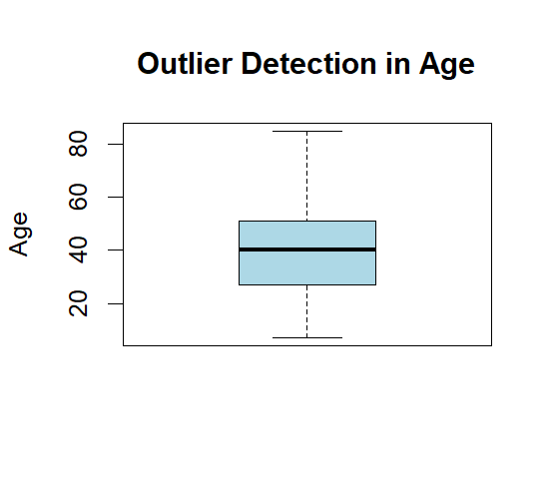

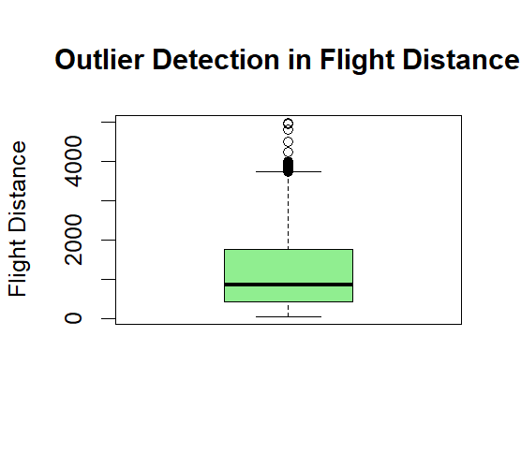

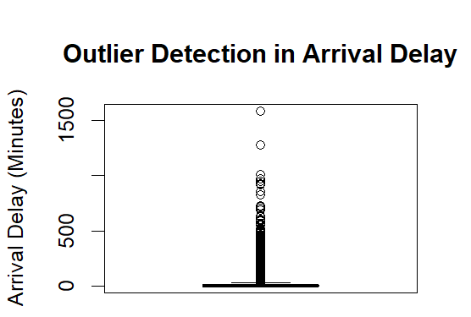

6.2 Outlier Count
R code:
length(boxplot.stats(raw_data$age)$out)
length(boxplot.stats(raw_data$flight_distance)$out)
length(boxplot.stats(
raw_data$arrival_delay_in_minutes
)$out)
Insert Table 3: Outlier Detection Results
Variable | Potential outliers
Age | 0
Flight distance | 2,291
Arrival delay | 13,954
Show the three outlier counts.
6.3 IQR Calculation
This section is important. Include the formula and your actual calculations.
IQR formula:
\[ IQR=Q3-Q1 \]
\[ Lower=Q1-1.5(IQR) \]
\[ Upper=Q3+1.5(IQR) \]
Your actual arrival delay values:
Measurement | Value
Q1 | 0
Q3 | 13
IQR | 13
Lower limit | -19.5
Upper limit | 32.5
R code:
Q1 <- quantile(
raw_data$arrival_delay_in_minutes, 0.25
)
Q3 <- quantile(
raw_data$arrival_delay_in_minutes, 0.75
)
IQR_value <- IQR(
raw_data$arrival_delay_in_minutes
)
lower_limit <- Q1 - 1.5 * IQR_value
upper_limit <- Q3 + 1.5 * IQR_value
lower_limit
upper_limit
Insert Screenshot 8
Show your actual output:
25%
-19.5
75%
32.5
The IQR method identified potential outliers in the arrival delay variable. The calculated lower and upper limits were -19.5 and 32.5 minutes. Observations above 32.5 minutes were identified as potential outliers. These values were retained because unusually long flight delays may represent genuine operational conditions.
7. Data Normalization
Min-Max normalization was applied to numerical variables to transform their values into a common range between 0 and 1. Three variables were normalized: age, flight distance, and arrival delay. New columns were created while preserving the original variables.
R code:
raw_data$age_normalized <-
(raw_data$age - min(raw_data$age)) /
(max(raw_data$age) - min(raw_data$age))
raw_data$flight_distance_normalized <-
(raw_data$flight_distance -
min(raw_data$flight_distance)) /
(max(raw_data$flight_distance) -
min(raw_data$flight_distance))
raw_data$arrival_delay_normalized <-
(raw_data$arrival_delay_in_minutes -
min(raw_data$arrival_delay_in_minutes)) /
(max(raw_data$arrival_delay_in_minutes) -
min(raw_data$arrival_delay_in_minutes))
Insert Table 4: Normalization Results
Variable | Minimum | Maximum
Age normalized | 0 | 1
Flight distance normalized | 0 | 1
Arrival delay normalized | 0 | 1

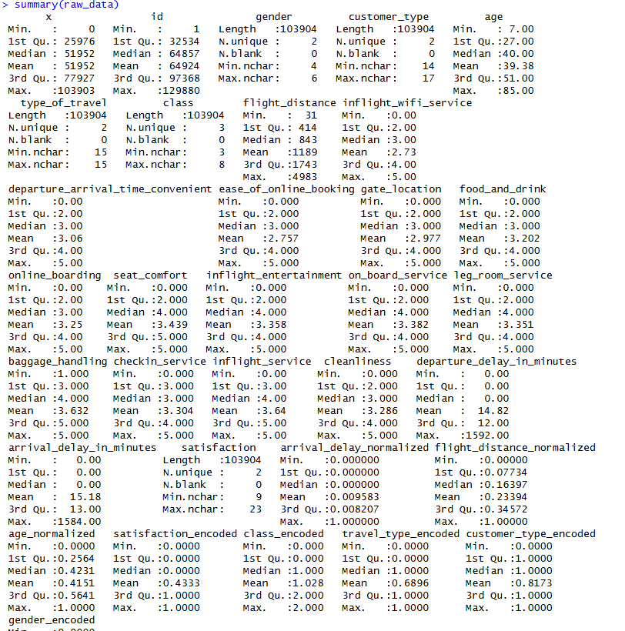

8. Categorical Encoding
Categorical encoding was performed to convert text-based variables into numerical representations. This makes the data suitable for further statistical analysis and machine-learning applications. New encoded columns were created without deleting the original categorical variables.
Insert Table 5: Categorical Encoding
Variable | Category | Encoded value
Gender | Female | 0
Gender | Male | 1
Customer type | Disloyal Customer | 0
Customer type | Loyal Customer | 1
Travel type | Personal Travel | 0
Travel type | Business travel | 1
Class | Eco | 0
Class | Eco Plus | 1
Class | Business | 2
Satisfaction | Neutral or dissatisfied | 0
Satisfaction | Satisfied | 1
R code:
raw_data$gender_encoded <- ifelse(
raw_data$gender == "Male", 1, 0
)
raw_data$customer_type_encoded <- ifelse(
raw_data$customer_type == "Loyal Customer", 1, 0
)
raw_data$travel_type_encoded <- ifelse(
raw_data$type_of_travel == "Business travel", 1, 0
)
raw_data$class_encoded <- as.numeric(
factor(raw_data$class,
levels = c("Eco", "Eco Plus", "Business"))
) - 1
raw_data$satisfaction_encoded <- ifelse(
raw_data$satisfaction == "satisfied", 1, 0
)
Insert Screenshot 10
Show your actual output of:
head(raw_data[, c(
"gender", "gender_encoded",
"customer_type", "customer_type_encoded",
"type_of_travel", "travel_type_encoded",
"class", "class_encoded",
"satisfaction", "satisfaction_encoded"
)])
Caption: Figure 7: Categorical variables and their encoded values.
8.1 Encoding Verification
Satisfaction | Encoded value | Passengers
Neutral or dissatisfied | 0 | 58,879
Satisfied | 1 | 45,025
Total |  | 103,904
Insert Table 7: Class Distribution
Class | Encoded value | Passengers
Eco | 0 | 46,745
Eco Plus | 1 | 7,494
Business | 2 | 49,665
Total |  | 103,904
9. Final Data Validation
After completing the data-cleaning and preprocessing operations, final validation was performed to check the dataset dimensions, missing values, duplicate records, and variable structure. This ensures that the transformed dataset is ready for further exploratory data analysis.
R code:
dim(raw_data)
sum(is.na(raw_data))
sum(duplicated(raw_data))
str(raw_data)
summary(raw_data)
Insert Screenshot 11
Important: The dataset originally had 25 columns. Because you added three normalized and five encoded columns, your final dataset should have more columns. Run dim(raw_data) to obtain the exact number.
9.1 Save the Cleaned Dataset
R code:
write.csv(
raw_data,
"airline_cleaned_dataset.csv",
row.names = FALSE
)
To check where it is saved:
getwd()
Insert Screenshot 12
Show the final CSV file or RStudio data viewer using:
View(raw_data)
Caption: Figure 8: Final cleaned airline passenger dataset.
10. Conclusion
Report explanation:
The airline passenger dataset was successfully inspected and processed using R. The initial dataset contained 103,904 observations and 25 variables. Missing-value analysis identified 310 missing values in the arrival delay variable, which were handled using mean imputation. No duplicate records were identified. Potential outliers were examined using the IQR method and retained because they may represent genuine flight conditions. Min-Max normalization was applied to numerical variables, and categorical encoding was performed on five variables. The original columns were preserved alongside the newly created columns. The resulting dataset is prepared for further exploratory data analysis and visualization.

